**Portfolio Project**

Brady Chin

Colorado State University Global

CSC500-1: Principles of Programming

Dr. Steven Evans

July 7th, 2024

**Portfolio Project**

We continued to build on the milestone projects to create the portfolio project. With small modifications, the project is now completed.

**Takeaways**

When this course first started, I looked ahead to the portfolio project and I was intimidated by it. At first glance, I was pretty confused by it. After completing it, I have a lot more confidence in my programming ability. I’m planning on using parts of code in this project as a template in future projects while also improving on them.

What I found most helpful with this project was working with classes (Colorado State University Global, 2024). Classes have confused me in the past and this project was a great exercise on how to pass information through classes.

**GitHub Repository**

GitHub Repository: [LINK](https://github.com/bradychin/csu-global-projects/tree/fd4a43c174252f8d07d39c497e750a4846650272/Principles%20of%20Programming/Portfolio%20Project)

Portfolio Project: [LINK](https://github.com/bradychin/csu-global-projects/blob/fd4a43c174252f8d07d39c497e750a4846650272/Principles%20of%20Programming/Portfolio%20Project/PortfolioProject.py)

Pseudocode: [LINK](https://github.com/bradychin/csu-global-projects/blob/fd4a43c174252f8d07d39c497e750a4846650272/Principles%20of%20Programming/Portfolio%20Project/PortfolioProjectPseudocode.txt)

**Screenshots**

Prompt user for name and date: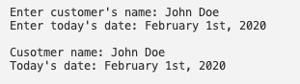

add_item():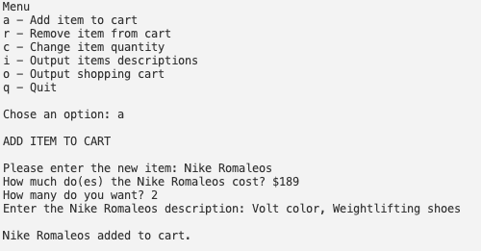

remove_item():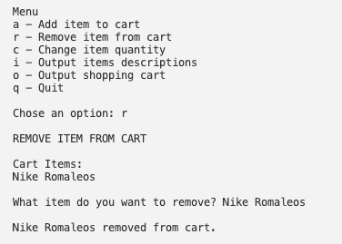

modify_item():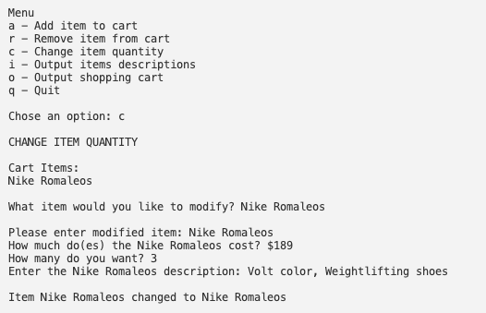

Quantity was changed from 2 to 3.

**References**

Colorado State University Global (2024, May 13th) *8.2 Developing Classes.*

<https://csuglobal.instructure.com/courses/93533/pages/8-dot-2-developing-classes?module_item_id=4786712>